UPPWISE INDIA

www.uppwise.com



**Quaterly Development Planning**

**Q1-2024**

**Feature: Execution Management – Vendor Time Tracking**

**Feature Title:**

Execution Management – Vendor Time Tracking

**Priority:**

Medium

**Submitted By:**

AXA

**Target Users:**

External Vendors

**Feature Description:**

In this feature development we are integrating the whole vendor Time Tracking application in the SPM with all the posibility permissions and required functionality. Below are the acceptance criteria or kind of workflow of the development.

**Acceptance Criteria:**

Based on the discussion and understanding of Vendor TT Management, I added the steps which are required to fullfill the development criteria based on requirements.

**Flow of VTT**

**Supplier Section Integration:**

* Introduce the supplier section within the standard code under the general section.
* Display a list of suppliers to the user.
* Enable editing of supplier details which opens an edit form.
* In the edit form, allow the assignment of users to the supplier as resources by selecting.

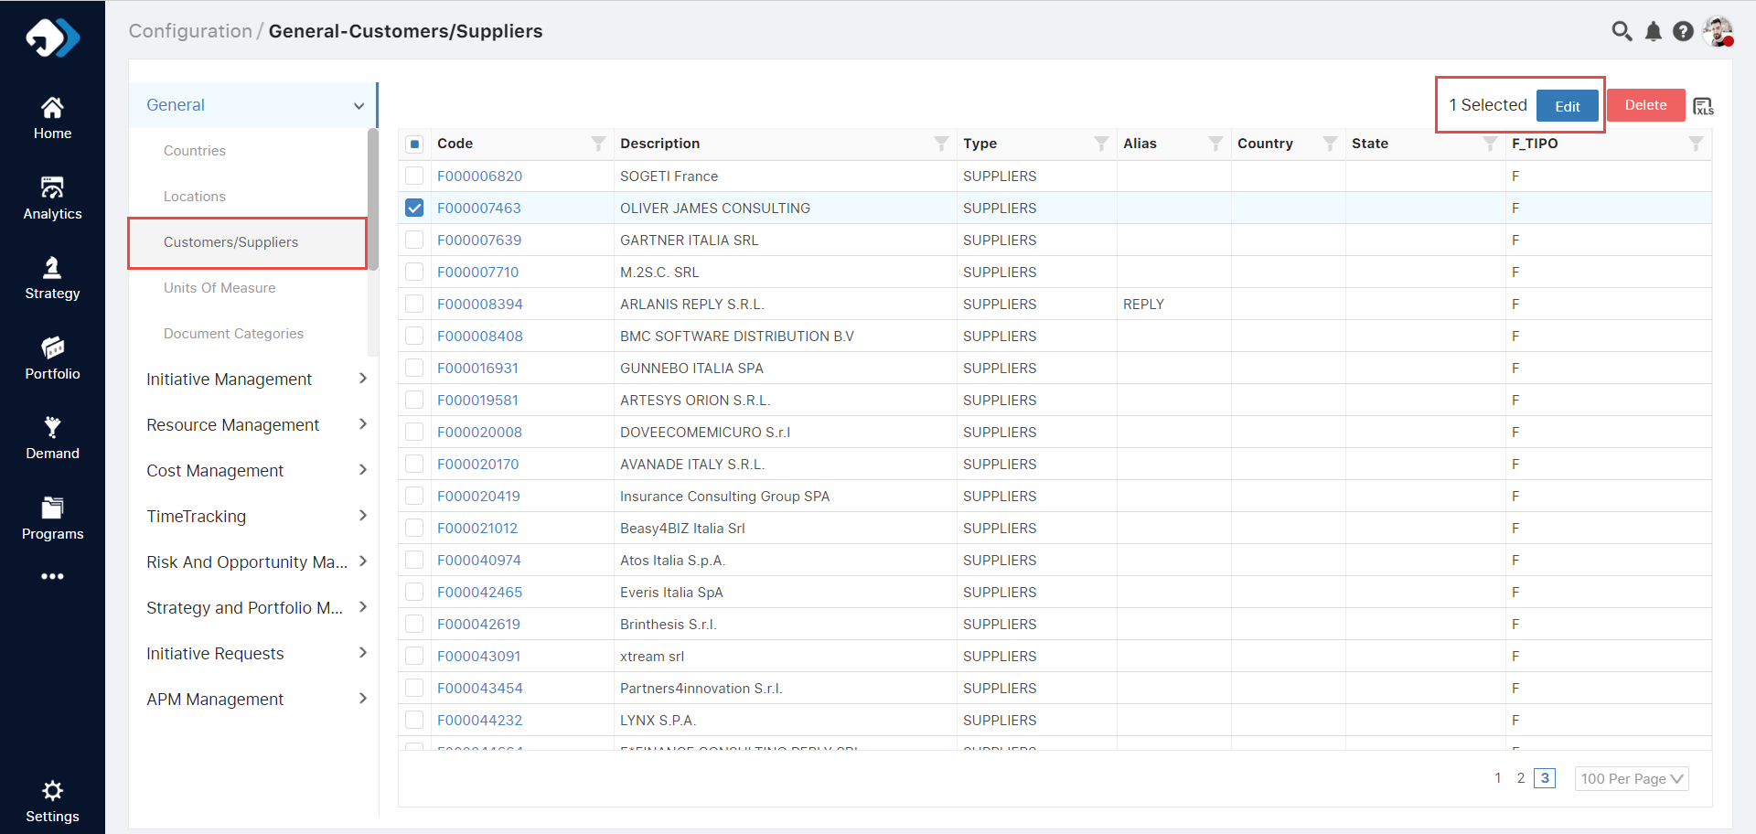

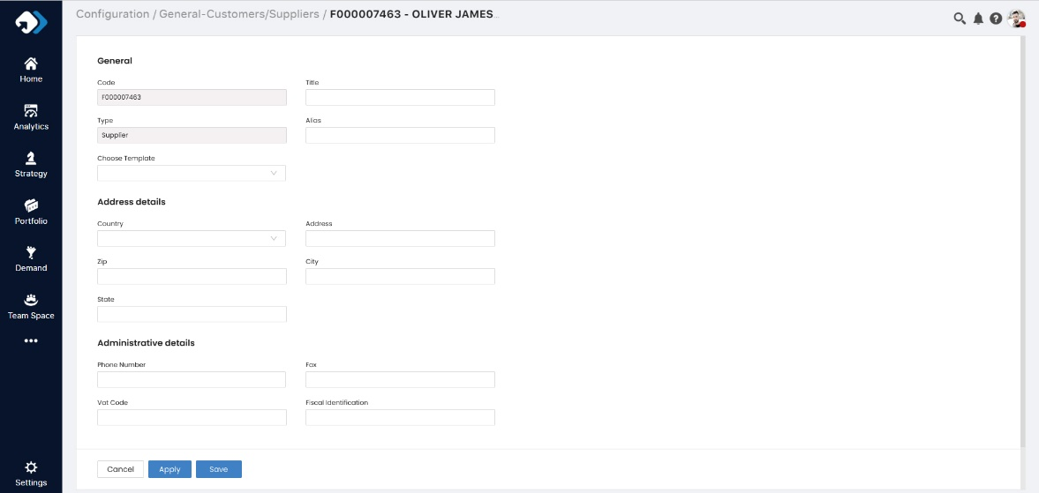

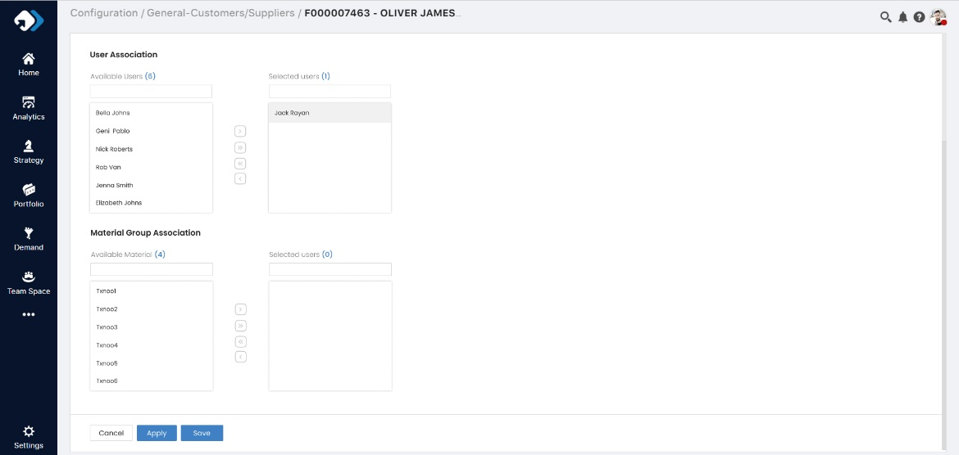

**Permission Assignment:**

* Allow the assignment of permissions to suppliers.
* This functionality should be accessible through the role edit page under the role configuratin at TimeTracking tab.
* Permissions include full control or restricted access.

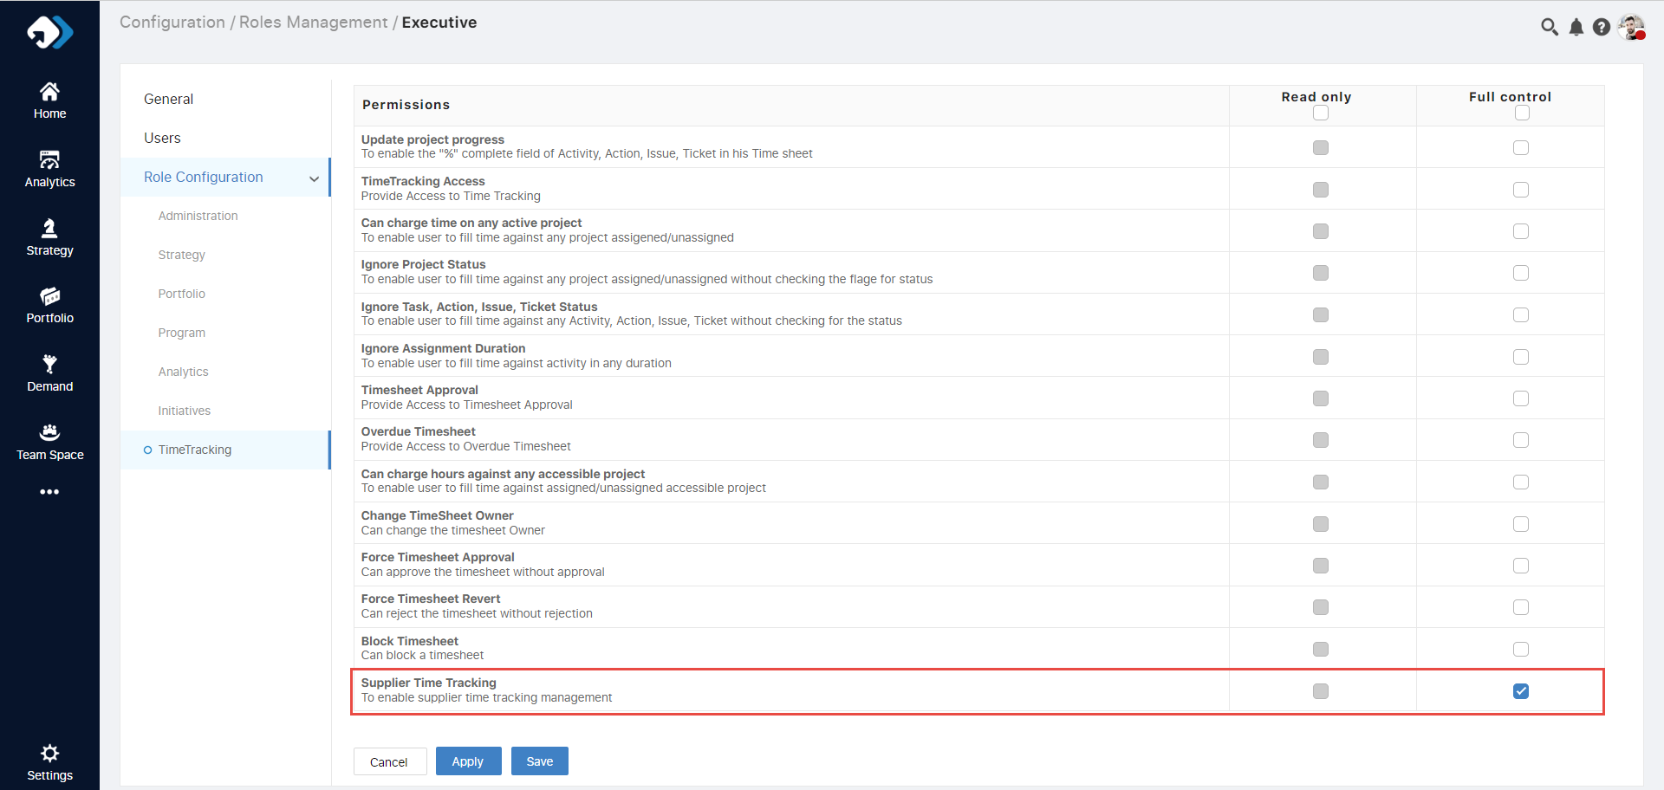

**New Menu Icon:**

* Introduce a new menu icon called "Vendor TT" or "Supplier".
* Clicking on this icon will open the supplier timesheet.

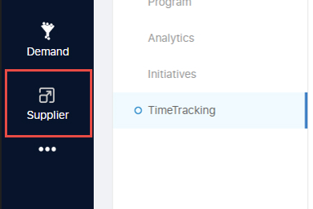

**Timesheet Management:**

* Suppliers can only view their own timesheets.
* Admins can view all timesheets, including data on pending and approved entries.

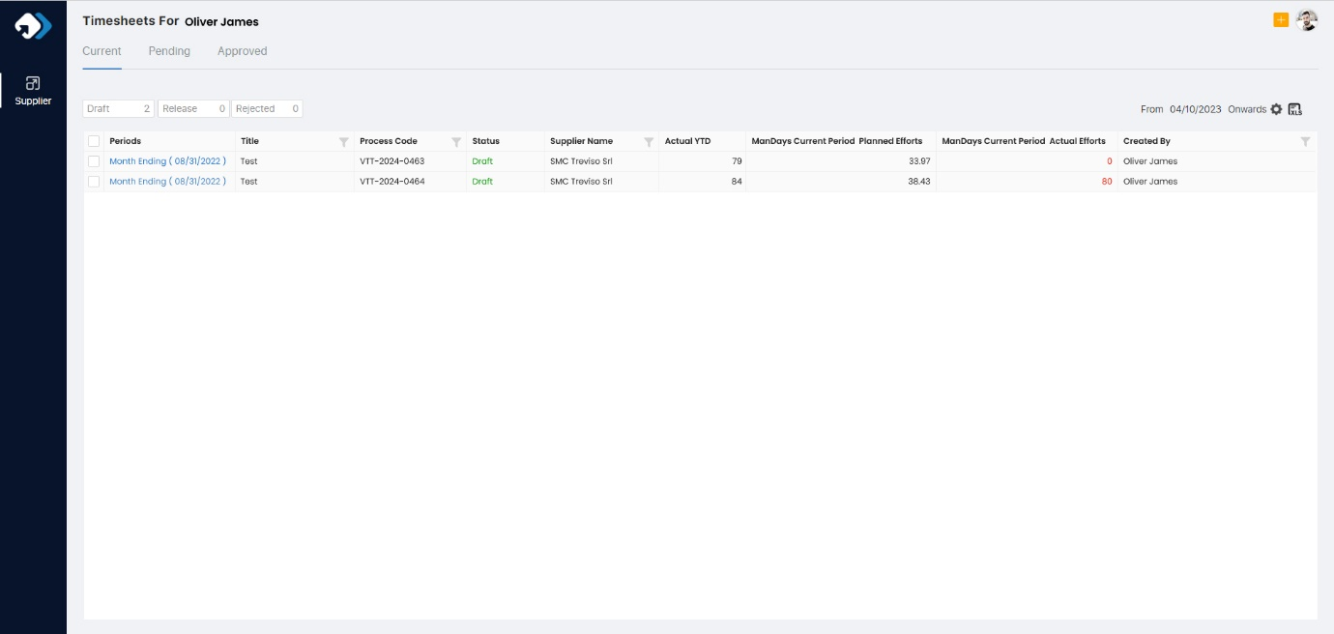

**Timesheet Creation:**

* Upon opening the timesheet page, assigned resources can create timesheets through a designated create icon.
* Users must fill out fields and choose the monthly date, as timesheets are created on a monthly basis.
* The supplier's name should automatically be fetched if the user is allocated as a resource.
* No specific validation is required during timesheet creation.

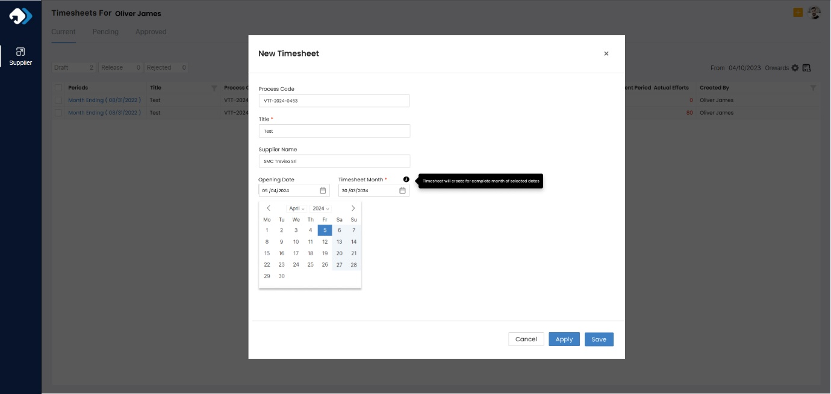

**Data Entry and Approval:**

* Users can add actual efforts based on pre-allocated projects.
* They can save or release for approval.
* Project managers can approve timesheets after reviewing them.
* Above over the info icon can see the time tracking details

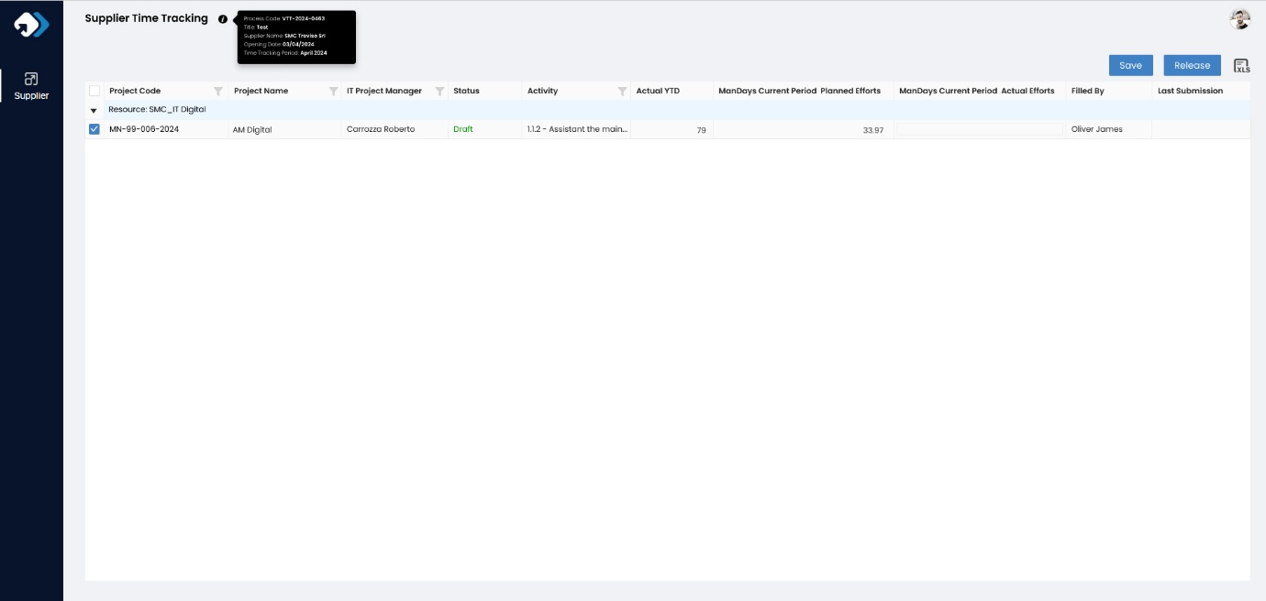

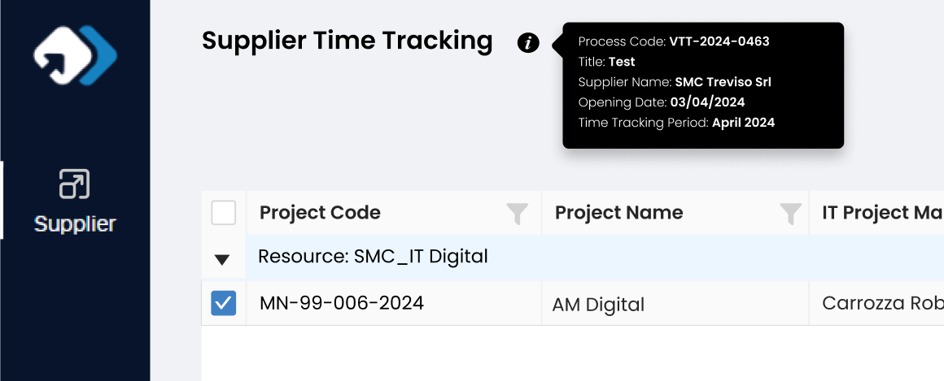

Also need to create resource and assignment over the project and define the approval permission for the PM under the supplier.

1. **Resource Creation and Configuration:**

* Create a generic resource for each vendor with specified attributes.
* Define a calendar for each resource with no working hours per day and 0% availability.
* Configure users with mandatory fields.

1. **Resource Assignment to Projects/Ideas:**

* Assign external generic resources to projects/ideas using the Workspace tab.
* Ensure at least one external generic resource per area is allocated on the same project as a generic resource per area of another vendor.

1. **PM IT Approval and Release:**

* PM IT reviews timesheets, enters comments, and approves or rejects rows.
* When rejecting rows, comments are mandatory before saving.
* After rejection and saving, the "Submit to Vendor" option becomes available.
* PM IT can edit "Rejected" rows' "Current Period Actual Effort" fields.
* PM IT approves rows, and once all are approved, the form can be released.
* If all lines are approved, PM IT initiates the release, triggering email notification to PM IT for approval.

1. **Final Approval and Form Locking:**

* All involved IT PMs must approve the released form.
* If only some rows are approved, the approved ones transition to "Approved" status while the others retain their previous status.
* If all rows are approved, IT PMs can release the form.
* After releasing, the form becomes uneditable by any PM IT.

**Requirements on VTT:**

**Code Modification:**

* Integrate the supplier section within the standard code under the general section.
* Implement edit forms for supplier details and user assignments.
* Add functionality to assign permissions to suppliers.

**UI Changes:**

* Introduce a new menu icon for accessing supplier timesheets.
* Design a timesheet page where users can create and manage the supplier timesheets.

**Permission Management:**

* Develop a system for managing permissions, accessible through the group edit page.
* Allow for the assignment of full control or restricted access.

**Data Handling:**

* Ensure that suppliers can only view their own timesheets, while admins have access to all.
* Implement data storage and retrieval for timesheets, including pending and approved statuses.

**Timesheet Creation and Management:**

* Design forms for creating timesheets with monthly date selection.
* Enable data entry for specific hours and project allocation.
* Implement functionality for saving and releasing timesheets for approval.

**Approval Workflow:**

* Enable project managers to review and approve timesheets.
* Designate actions for both users and project managers during the approval process.